National University of Computer and Emerging Sciences



Laboratory Manual

for

Programming Fundamentals

|  |  |
| --- | --- |
| Course Instructor | Mr. Waqas Mansoor |
| Lab Instructor(s) | Ms. Shazia Ahmed  Mr. Adeel Qayyum |
| Section | PF E |
| Semester | Fall 2020 |

Department of Computer Science

FAST-NU, Lahore, Pakistan

# Lab Manual 05

**Use of loops, break, continue…**

**Problem 1:**

Using While loop, write a C++ program to find whether a number is prime or not?

(A prime is the number is not divisible by any number except itself and 1).

**Problem 2:**

Write a C++ program where you'll ask the user to enter as many numbers as he wants. As soon as he wants to stop inputting, he'll enter -1. If the user enter number greater than 15, ignore that entry.

Now you’ll have to print the average of all the numbers that the user entered.

**Sample Run:**

|  |
| --- |
| Enter a number: **3**  Enter a number: **6**  Enter a number: **0**  Enter a number: **4**  Enter a number: **9**  Enter a number: **5**  Enter a number: **2**  Enter a number: **1**  Enter a number: **7**  Enter a number: **11**  Enter a number: **-1**  **Average of the entered numbers is: 4.8** |

**Problem 3:**

Write a program that checks if the number is Palindrome or not.

**Palindrome**: A palindrome is a word, number, phrase, or other sequence of characters which reads the same backward as forward, such as madam or racecar or the number 10201 **For example:**

11211 is palindrome

1222 is not a palindrome.

4444 is a palindrome.

**Problem 4:**

The ancient Greeks classified numbers geometrically. For example, a number was called “triangular” if that number of pebbles could be arranged in a symmetric triangle as shown in the figure below. The first ten triangular numbers are 1, 3, 6, 10, 15, 21, 28, 36, and 45. Write a program that takes as input a number N and prints whether it is triangular or not.

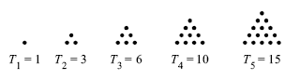

**Problem 5:**

The greatest common divisor (GCD) of two integers is the largest integer that evenly divides each of the numbers. Write a C++ program that gives the greatest common divisor of two positive integers. Take these two numbers from the user.

Remember that the GCD of two numbers can be computed using Euclidean Algorithm as follows

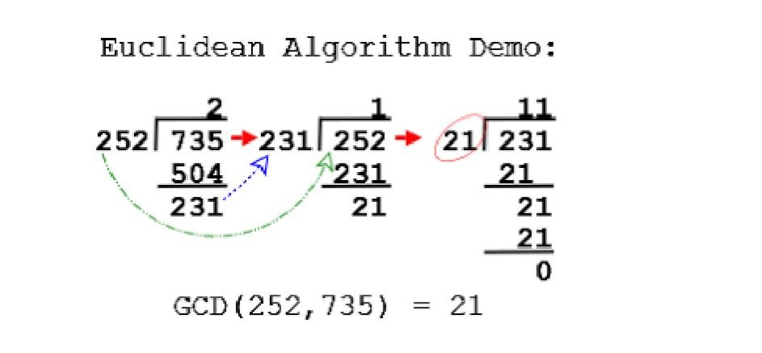

**Sample Run:**

**Input num1:** 252

**Input num2:** 735

**Output**

**GCD:** 21

**Problem 6:**

Find the factorial of a non-negative number n entered by user using for-loop. Your program should display 1 for 0.

**Sample Run:**

**Enter a non-negative number: 5**

**Output** : Factorial of 5 is = 120

**Problem 7:**

Write a program that asks the user to enter an alphabet and check if it is vowel or consonant. Remember vowels are A, E, I, O, U and a, e, I, o, u.

**Hint:** To get input of alphabet use **char** data type.

**Problem 8:**

Write a C program to check whether a number is even or odd using switch case.

**Problem 8:**

Write a program that prints ASCII of integers from 0 to 255.

**Problem 9:**

Write series of odd numbers using for loop up to a limit entered by user.

**Sample Run:**

**Enter a number: 10**

**Output** : 1

**3**

**5**

**7**

**9**